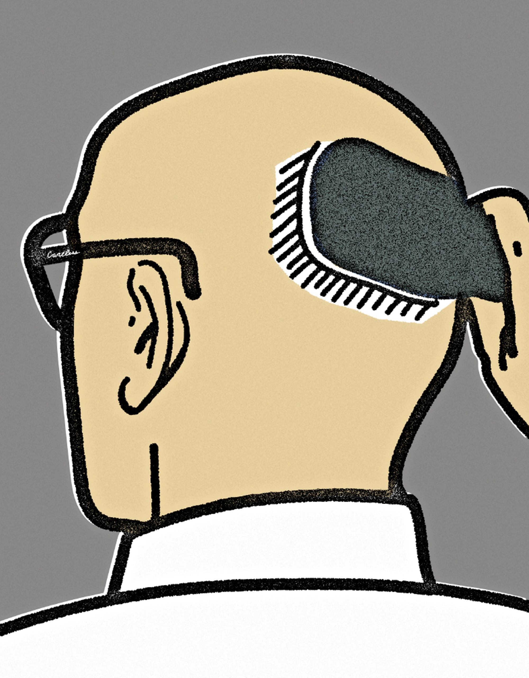

The Hairless Are Careless

**By**[**Colin Barrett**](https://www.newyorker.com/contributors/colin-barrett)

*This is one of a series of flash-fiction pieces that The New Yorker will be presenting throughout the summer. Read the rest of the stories*[*here*](http://www.newyorker.com/books/flash-fiction)*.*

“Prejudicial of me, I know,” said Tommy, nodding at the man in front of them at the pump, filling up his car’s tank (bald), “but I can’t help think of the hairless as careless.”

“Like how?” Ernie said.

“Like they’ve lost their hair,” said Tommy.

“As in it’s their own fault, you mean,” said Ernie.

“Like they’ve misplaced it, of their own accord. You lose a thing of your own accord, in most cases.”

“You mean like if you sort of stop noticing it in the mirror,” Luke, who loafed at a diagonal angle across the back seat of Tommy’s car, as if he were asleep, bestirred himself now to chip in. “Like if you get the same haircut every time and begin to take your hair for granted, and sort of stop seeing it, in a sense, and so but one day it disappears.”

“Like you were deep down wishing for it,” said Ernie.

“Maybe not wishing for it, exactly,” muttered Tommy, although that *was* kind of what he thought. He’d always had this notion about hair—that it was sentient, that it somehow possessed the propensity to tell whether it was appreciated or not—as far back as he could remember. It was just a dumb notion. One of Tommy’s uncles had been a nemesis of his when he was a kid. The uncle, pale and pimpled, as sinisterly skinny as an adolescent, even in his forties, had been bald, and Tommy had always wanted to impute that baldness to some inherent deficiency of character.

“In any case, I don’t think that’s the way it works,” said Ernie.

“I understand that’s not the way it works,” said Tommy.

•

The pump’s nozzle in hand, the bald man was staring into the distance with the unprepossessing vacancy of someone urinating at a trough, his pink tie snagged up over his shoulder and flapping in the breeze like the tongue of a trotting dog. He was actually young, around Tommy, Ernie, and Luke’s age—late twenties—but there was a weathered quality to the skin covering his skull, patches of paler and darker pigment, that made Tommy wonder if the man had recently had chemo.

It was 5 p.m. on a Friday. The three were due to start the evening weekend shift at the Oasis water-cooler factory in an hour. Ernie and Tommy were machine operators. Luke was on the assembly line, sticking the warning stickers on the interior frames of the coolers as they rolled by him at a rate of one every three seconds. Luke was a qualified electrician, but had shown up to work insufficiently sober one too many times, botched the wiring in one house too many—and then had to take whatever he could get. Most people stuck the gruelling monotony of the assembly line for only a few months: they either got promoted elsewhere or quit. Luke had been on the line for eighteen months straight. As far as Tommy was concerned, it had turned the lad insane. Tommy and Ernie’s job was also boring, but in a more involved way. Every few weeks, there was some adjustment or recalibration to the cutting equipment that needed to be implemented, plus they were in charge of a team of four lifters—teen-agers, mostly, who pulled the still-hot casings out of the molds. When things threatened to get too much, they would send the youngsters on errands for glass hammers, rungless ladders, sky hooks.

•

The bald man went into the petrol station, came back out licking an ice-cream cone, and got into his motor. Unreliable

“That’s actually a tasty car,” Ernie pointed out.

“Rental,” said Luke.

“How do you know?” asked Tommy.

“You know,” said Luke.

•

On their first break, at 8 p.m. that night, smoking outside the warehouse entrance, Tommy and Ernie spotted the bald man exiting the front offices, his white shirt and pale head giving him a lunar aspect as he crossed the factory lot. There was a weird atmosphere in the plant that weekend, rumors spreading on the floor with a sour excitability, conjecture traded and revised at every canteen break. By Monday morning, the employees had put the pieces of a picture together. The consensus was that the bald man was an American, an emissary from the central office over in Massachusetts or Minnesota, Milwaukee or Manitoba, or wherever the hell the central office was, and that he was here to inform them the factory was going to go. On Monday afternoon, management sent out an e-mail advising of an *exciting*, company-wide *root and branch realignment of resources,* which would allow for a *dramatic expansion* in the company’s *productivity and scale* but that, also, somehow, involved cutting the human staff in the Irish plant by sixty per cent.

•

“Actually, the factory is fine. It’s the employees that are fucked,” Ernie glossed bitterly, the three sitting in Staunton’s pub the following Monday night.

“We’re being automated,” said Tommy.

“I can’t believe we are being automated,” said Luke, delighted at an impending return to unemployment, so long as it wasn’t his fault.

“The fatuous head on him, coming out of the petrol station,” said Ernie. “Eating an ice-cream cone, the contented little motherfucker.”

“Someone had to do it,” said Tommy.

“I wish you hadn’t pointed him out, though,” said Ernie.

“What did I do?” said Tommy.

“You had to point him out like that. Bring him up. We hadn’t seen him until then.”

Luke flagged down the barman, asked for three neat Jemmies.

“He’s right, though,” said Luke to Tommy. “It’s like you had to pass that remark on him—he didn’t exist until then. If you hadn’t opened your mouth, we wouldn’t have seen him in the forecourt; if we hadn’t seen him there, then it follows that we would also not have seen him in at work.”

“No bald bastard, no redundancies,” concluded Ernie.

“In that case, I take full responsibility,” said Tommy.

Luke was repeatedly ducking his arm forward and making a precise little gesture with his thumb and forefinger.

“See that,” he said. “I did that every three seconds of every hour, ten hours a day, five days a week, for the guts of the last two years.” He closed his eyes. “I do it in my sleep; I dream of the frames going by. After they bury me, I’ll wear a spot in the lid of the coffin making the same gesture.”

“But you’re already dead,” muttered Tommy.

“That is true,” said Luke.

“Nobody is lucky enough to ever die just the once,” said Tommy.

After a while, Luke said to Tommy, “What are you going to do?”

City was playing United on the flat-screen above the bar, but the sound was off. The movement of the players seemed weightless, somehow insubstantial, without the anchoring noise of the crowd and the commentary.

“Maybe give the Premier League another shot,” said Tommy. He’d gone to England when he was twelve, trialled at Everton, signed on for their academy, blown the knee out at fifteen, spent a year in physio, spent two years after that doggedly trialling: at Bury, at Rochdale, at Lincoln, at Hamilton fucking Academical, then was clinically depressed from eighteen to twenty-two, then got the Oasis job.

“Sure look,” said Ernie in that way the Irish had, the rising cadence suggesting a phrase that preceded a consolation.

Luke looked at Ernie. Tommy looked at Ernie. Ernie opened his mouth, and nothing came out.

[*Colin Barrett*](https://www.newyorker.com/contributors/colin-barrett)*is the author of two short-story collections, “*[*Young Skins*](https://www.amazon.com/dp/B00F9IP24W/ref=dp-kindle-redirect?_encoding=UTF8&btkr=1)*” and the forthcoming “*[*Homesickness*](https://www.amazon.com/Homesickness-Colin-Barrett-ebook/dp/B09JTTRK6S/)*.”*

1. Is the impression the story gives more comic or more tragic?

I think that the story gives more tragic. Tommy, Ernie and Luck were all at age about late twenties while they were machine operators facing cutting of human staffs. They were replaced by automatics such as robots and technologies. They have no other work but only use the alcohol to anesthetize themselves in the pub. They have no chance to defy their fate, they are at the mercy of others.

1. Does this author seem to follow the classic fiction writing rule of “show, don’t tell”? How so? Or why not?

Yes. I think they seem to follow that rule. For example, I like the description of the bald man “his pink tie snagged up over his shoulder and flapping in the breeze like the tongue of a trotting dog…but there was a weathered quality to the skin covering his skull, patches of paler and darker pigment”, I think this is the padding for the part of the story shown that this unpleasant man cut of staffs. And also my favorite description of the down mood of Tommy and Luck after being cutoff: “City was playing United on the flat-screen above the bar, but the sound was off. The movement of the players seemed weightless, somehow insubstantial, without the anchoring noise of the crowd and the commentary.” The sense of weightless is not for the sports players, but them, since their future is unknown, with confusion and disorientation.

1. What dynamics (e.g. economic, social, political, global) does this story present that are very contemporary?

I think the story represent the technology development of being more and more automatic and causes people losing their jobs and replaced by robots and automation. This is a economic and society problem.

1. Could you argue that this story has a kind of socialist message? A “progressive” one? What aspects would seem to support or undermine that idea?

The message of “progressive” is shown because technology is developing, automatics is forming. But this idea is undermined because of people losing their jobs. In my aspect, I think progressive first means people’s rate of happiness increase while in this story, the “bald”, really means careless because he does not care whether others have jobs, but just to satisfy himself. A future with developed technology but less humanity care cannot be seen as “progressive” in my mind.

1. List 5 possible symbols in this story, OR create an exhaustive list.

Bald/ hairless: unhealthy, careless, selfish redundancies

Weightless: confusion

Luna (Lunar Moon): chill, pale white

Soccer ball: Tommy’s broken dream

Death: The low point of life

1. Did the title make you want to read this story? What did you think it might mean, or what did you imagine the story might be about before you read it? What may be its thematic significance to the story?

Yes. I think the title give me a feeling of a story similar to O Henry’s humorous story. I imagined the story might be a worker losing his hair in hard work (or maybe an IB student). I thought its thematic significance may be complaining about a careless man who is so careless that he lost his hair.